EXP 20
Aim
To sharpen an image using a Laplacian mask with a negative center coefficient.
Procedure
- Read the image.
- Define the Laplacian sharpening kernel.
- Apply the filter using filter2D().
- Display the sharpened image.
Code
import cv2
import numpy as np
img = cv2.imread("image1.png")
kernel = np.array([[0,-1,0],
[-1,5,-1],
[0,-1,0]])
sharp = cv2.filter2D(img,-1,kernel)
cv2.imshow("Original", img)
cv2.imshow("Sharpened Image", sharp)
cv2.waitKey(0)
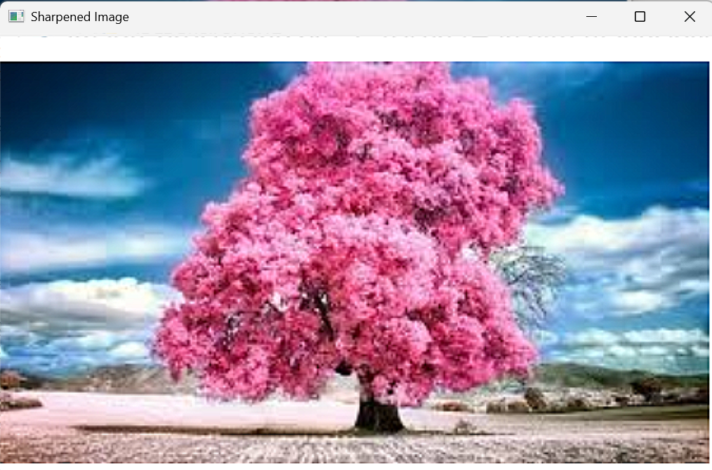
cv2.destroyAllWindows()

